# Develop software

1. Vscode：https://code.visualstudio.com/
2. Idea：https://www.jetbrains.com/idea/
3. Navicat：www.navicat.com.cn/download/navicat-premium

# Development environment configuration

The following is the development environment required to run the front-end (houtai, qiantai) projects. If your computer is already installed (configured), skip it.

## Front

### NVM

Front-end projects require node16 version, skip this step if you already have it installed.

If you have not installed it or the version is higher than 16, then install nvm first, which can dynamically switch the node version.

NVM download address：<https://github.com/coreybutler/nvm-windows/releases/download/1.2.2/nvm-setup.exe>

It is installed by default, and you need to restart your computer after the installation is completed.

After the computer is booted, open the cmd console and type nvm -v If the following picture appears, it means that the installation is successful.

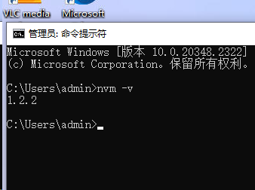

Run nvm install 16

The picture below shows that it is installed.

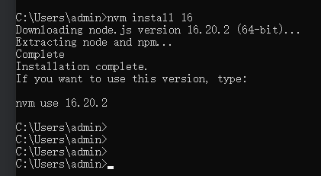

Run **nvm use 16.20.2**

After the switchover is complete, you can enter node -v to verify whether the switchover is successful

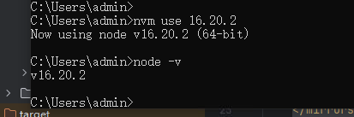

## back end

### JDK8

Download the IDEA development software (link at the beginning) and then choose to try it (skip if you have one).

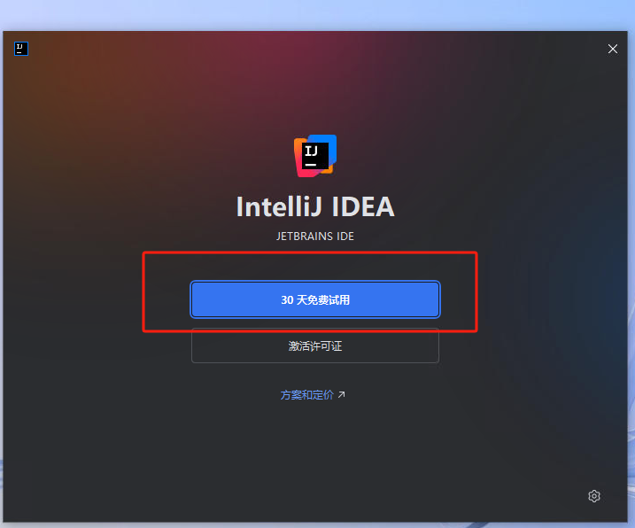

Please select the first one for the download version

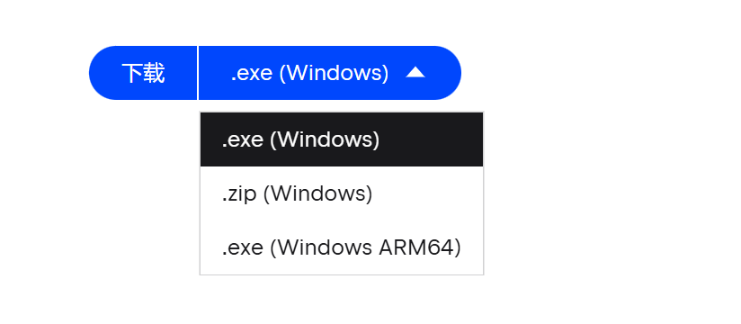

For the first download, skip Improt

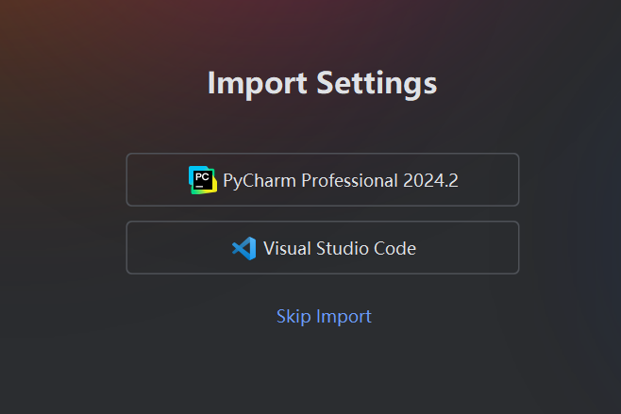

Then use idea to open the houduan project.

Click **File** Chose **Project Structure**。

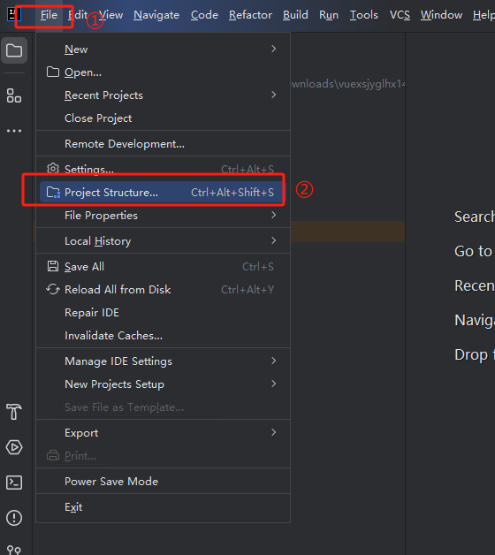

According to the prompt in the following figure, if there is JDK1.8 **(JDK8),** select it; If not, click Download JDK to download.

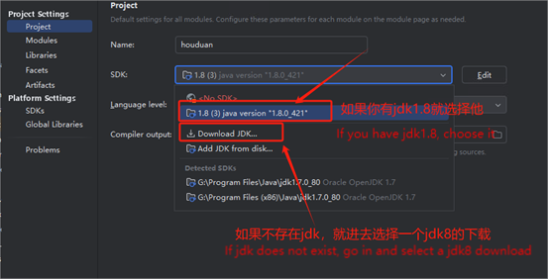

Version 1.8 and download it directly.

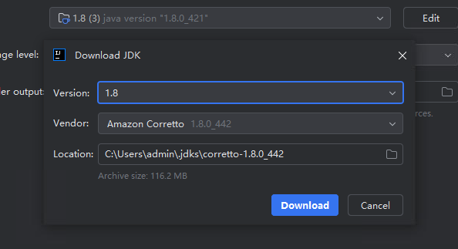

After downloading, you can select it.

You can configure it according to the picture

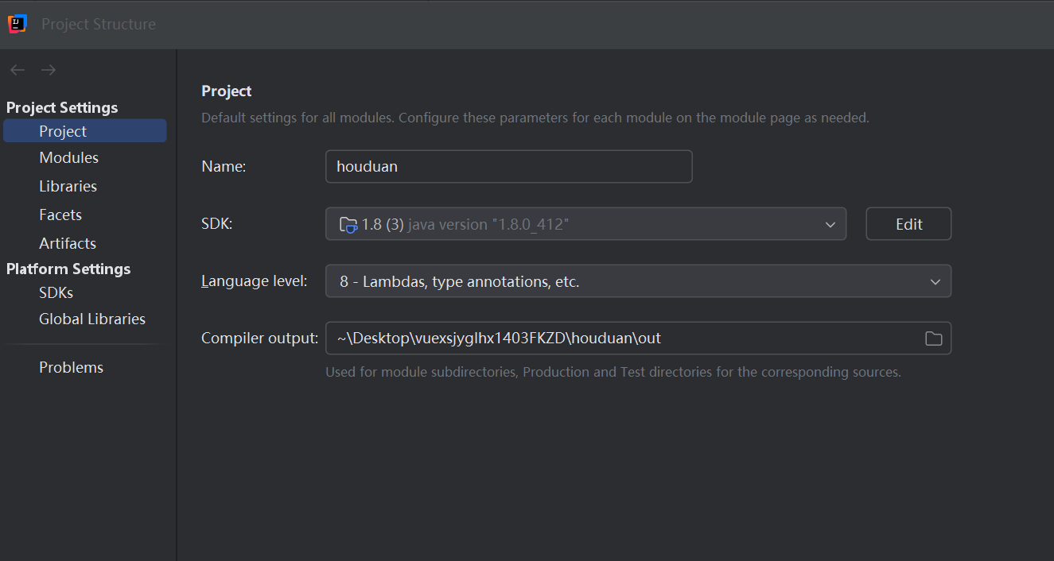

### Maven

Navigate to File from the top left corner of the Idea and find the Setting

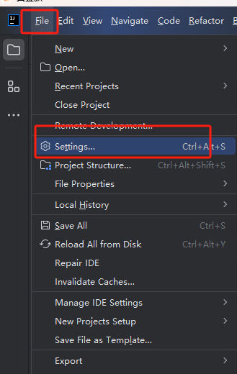

Then enter Maven, select according to the figure below, and click Confirm to automatically guide the package.

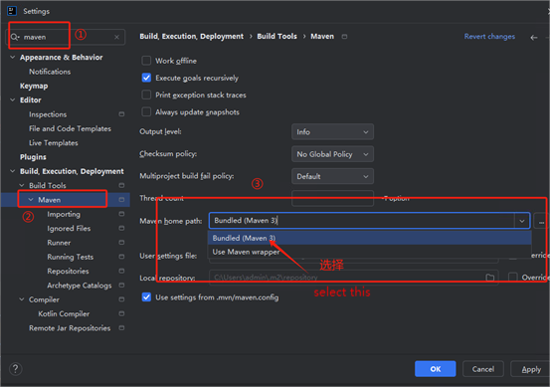

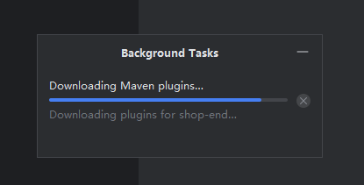

When the package is finished, you can start the project.

### Mysql8 (skip if you have mysql)

Use docker to install mysql8

Run the following command in the docker-desktop terminal

docker run -d \

--name mysql-container \

-p 3307:3306 \

-e MYSQL_ROOT_PASSWORD=root \

-e MYSQL_DATABASE=vuexsjyglhx1403FKZD1 \

--volume $(pwd)/data/mysql:/var/lib/mysql \

mysql:8.0 \

--default-authentication-plugin=mysql_native_password

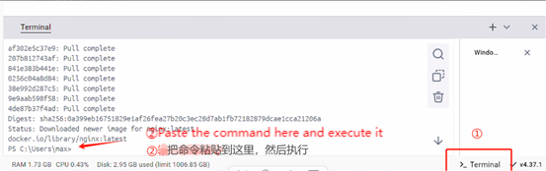

The account and password are all root. The port is 3307 and the database is vuexsjyglhx1403FKZD1

If you can't install it, install it manually

Manual installation tutorial <https://blog.csdn.net/Turniper/article/details/136658510> (The tutorial is in Chinese)

You only need to install MySQL, and you don't need to configure computer environment variables

### Navicat

Install Navicat first, and then select Trial.

Once the database is installed, use navicat to connect to Mysql**.**

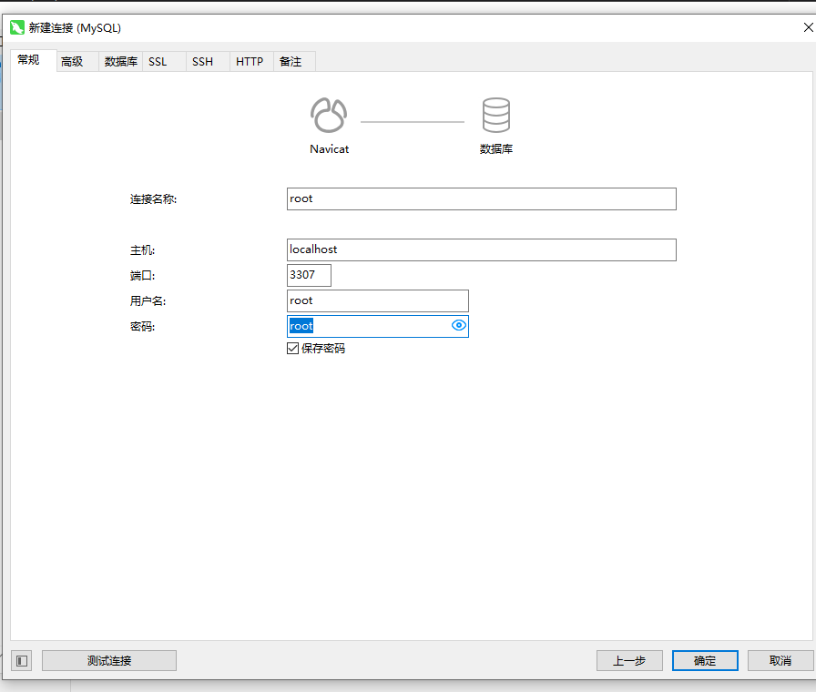

Then select the vuexsjyglhx1403FKZD1 database and import the database file. Follow the steps below. (If you don't have a vuexsjyglhx1403FKZD1 table, you need to create one first)

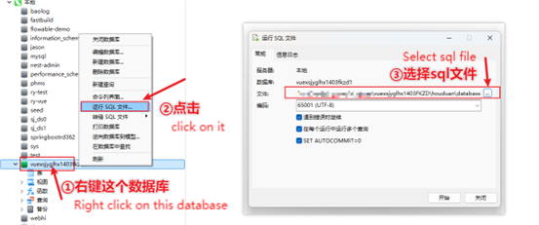

Sql：vuexsjyglhx1403FKZD\houduan\database

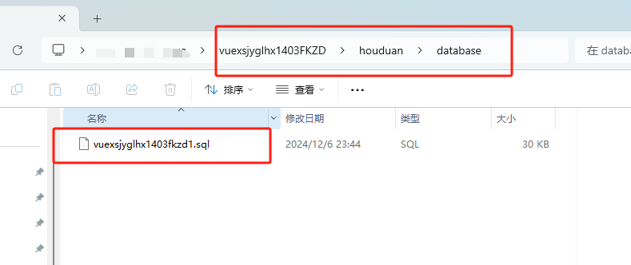

The import is completed as shown in the following figure.

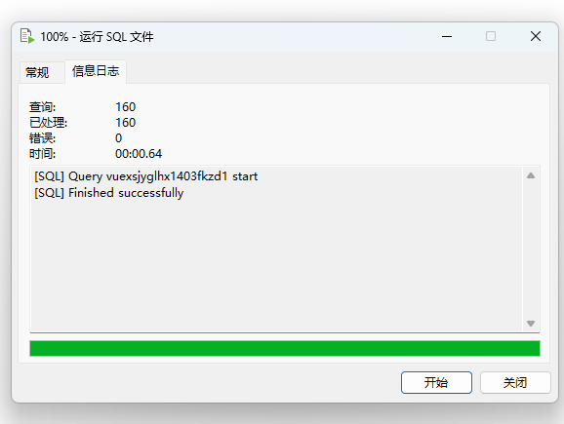

After the import is complete, modify the database information of the backend project (houduan).

Note:

1. If you already have MySQL installed, just change the information to yours (to import the database file).
2. **If you follow the above operation, you don't need to change** it.

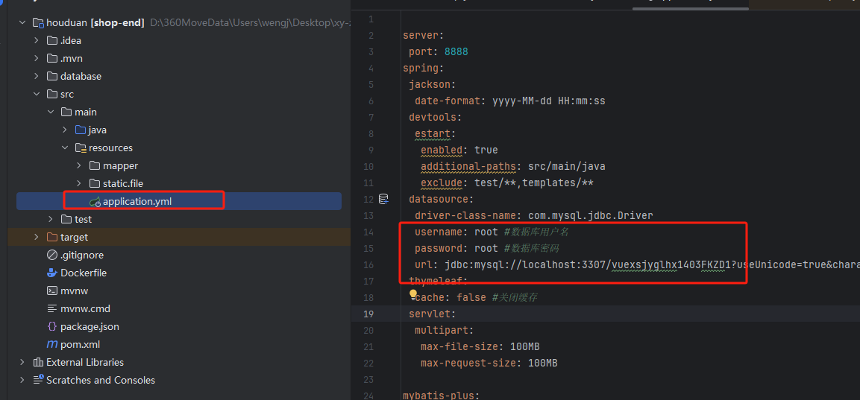

# Run the steps

## Back end

Just follow the image below to start the project.

Note that you need to import the Mysql database, **import the Maven package, and check whether the database connection information is accurate.**

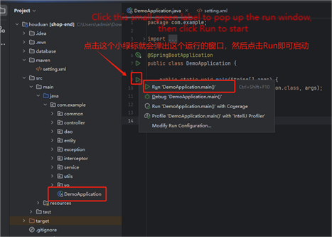

The following one appears to prove that the launch was successful.

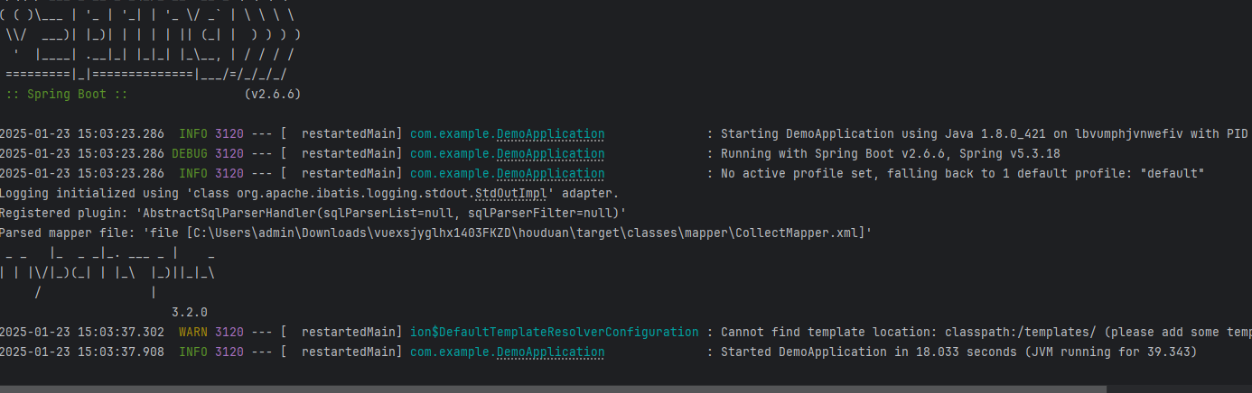

Then visit localhost:8888

The following one is OK.

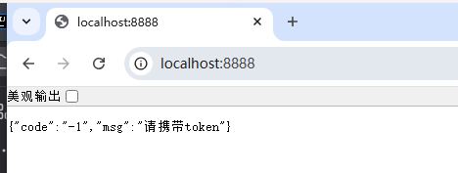

Note:

If the front-end is running fine, but you can't log in/load data normally, then check whether the database can connect normally and whether the database information is correct.

## Front

#### Qianths

Open the Qiantai project with vscode, and then do the following:

Run the npm run serve command in the console to start the foreground project

The following is a proof that the operation is successful.

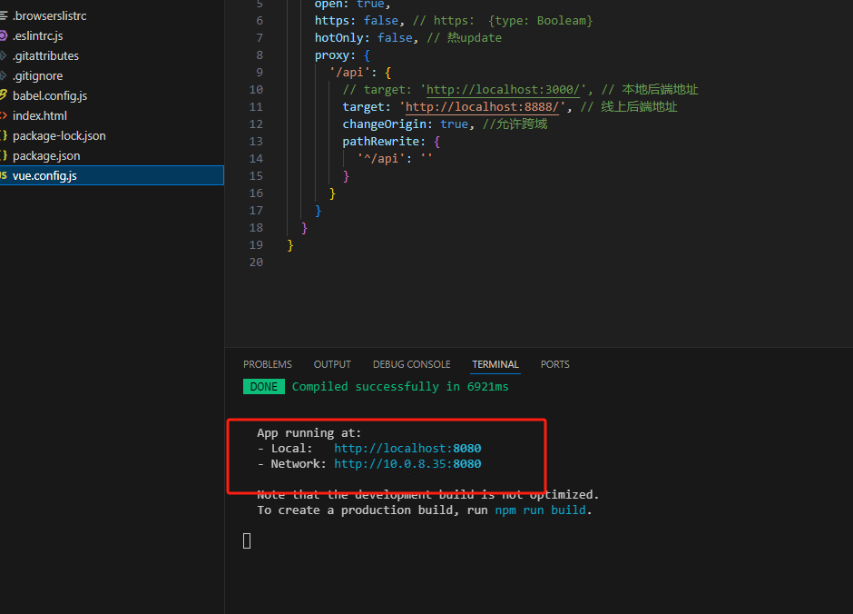

Visit: http://localhost:8080

If the data appears, it proves success

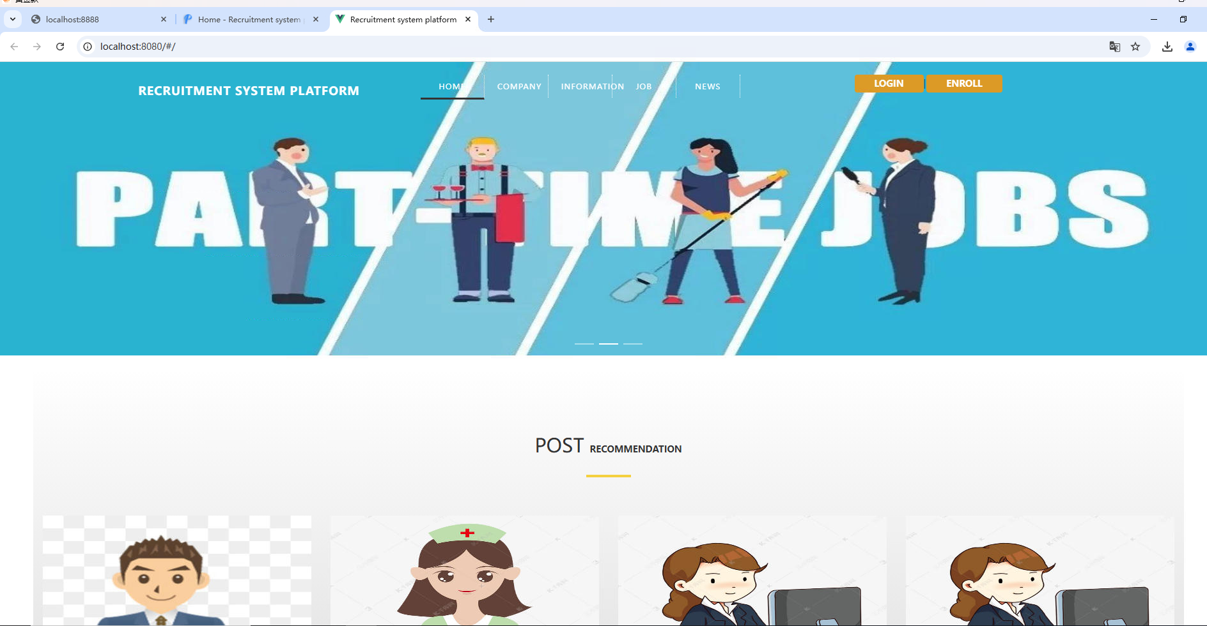

You can try to register an account to get in.

#### Houtai

Open the houtai project with vscode, and then do the following:

Run the npm run dev command in the console to start the foreground project

The following one appears to indicate that the startup is complete.

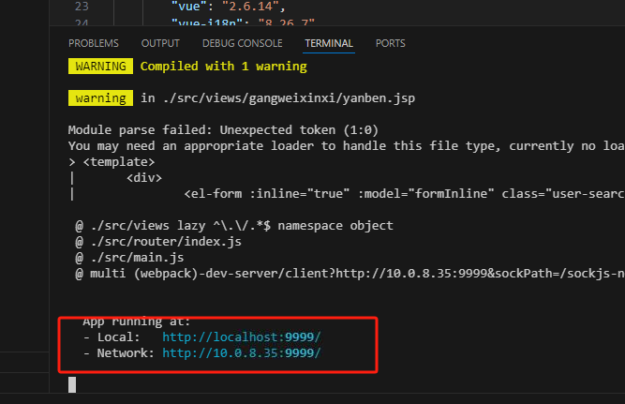

Visit <http://localhost:9999/>

The login window will appear, and the account and password are admin

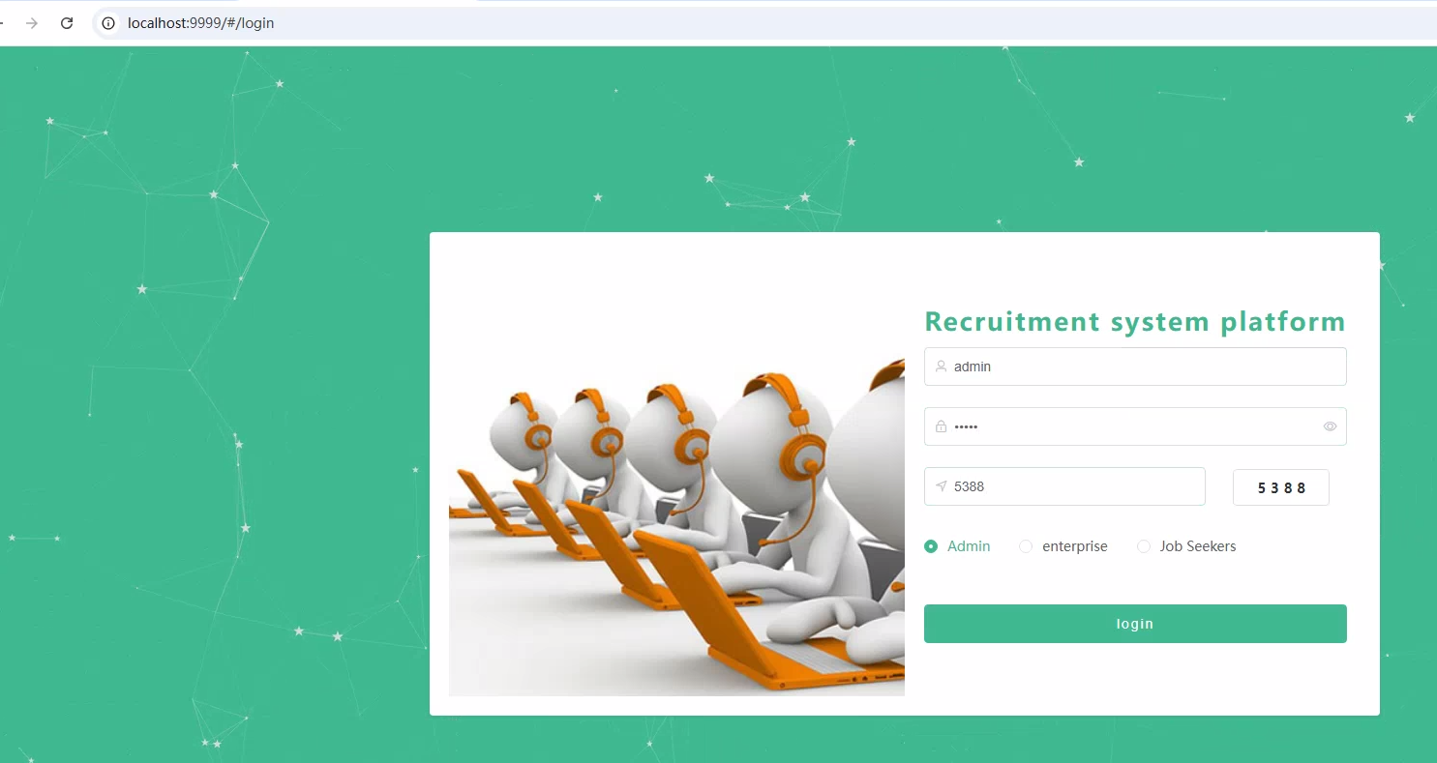

Login successful

